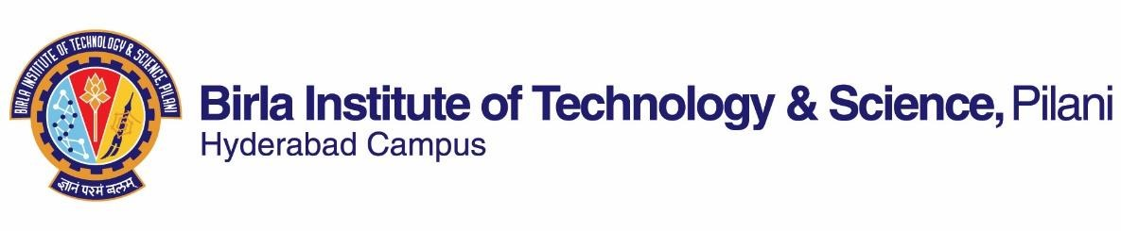

**SECOND SEMESTER 2021-2022**

# Course Handout Part-II

Date: 15-01-2022

In addition to Part-I (General Handout for all courses appended to the time table) this portion gives further specific details regarding the course.

*Course No.* : HSS F340

*Course Title* : Postcolonial Literature

*Instructor-in-Charge* : Prof. T Vijay Kumar

**Scope and Objective of the Course:** This course, introductory in nature, seeks to help students make sense of their postcolonial context through a study of its representation in literary and theoretical texts. The course will familiarize them with the key terms, concepts, issues, debates, and theories in postcolonial writing. Students will be encouraged to reflect on and revisit received notions and canonical texts from the perspective of their lived experience. Besides equipping them with the conceptual framework and analytical tools to read the ‘signs’ in colonial, postcolonial, and nationalist discourses, the course aims to foster, through lectures, debate, discussion, and assignments, self-reflection and the spirit of critical inquiry among students.

**Textbooks:**

1. McLeod, John. *Beginning Postcolonialism*. 2nd ed., Manchester UP, 2010.
2. Ashcroft, Bill, et al., editors. *Post-Colonial Studies: The Key Concepts*. 2nd ed., Routledge, 2007.

**Reference books**

1. Achebe, Chinua. *Things Fall Apart*. 1958. Penguin Modern Classics, 2001.
2. Ashcroft, Bill, et al., editors. *The Empire Writes Back: Theory and Practice in Post-Colonial Literatures*. 2nd ed., Routledge, 2002. New Accents Series.
3. Gandhi, Leela. *Postcolonial Theory: A Critical Introduction*. 2nd ed., Columbia University Press, 2019.
4. Loomba, Ania. *Colonialism/Postcolonialism*. Routledge, 2016. The New Critical Idiom Series.
5. Nandy, Ashis. *The Intimate Enemy: Loss and Recovery of Self Under Colonialism*. 2nd ed., OUP, 2009.
6. Young, Robert JC. *Postcolonialism: A Very Short Introduction*. OUP, 2003. Very Short Introductions Series.

NOTE: Text and reference books listed above will be supplemented with other resources, as and when needed, in the classroom. Students are expected to be familiar with the additional reading material as well.

**Course Plan:**

|  |  |  |  |
| --- | --- | --- | --- |
| **Lecture No.** | **Learning objectives** | **Topics to be covered** | **Chapter in the Text**  **Book** |
| 1-5  Unit I | Introduction to the prehistory of postcolonialism | Course overview, Commonwealth literature, Third World literature, New Literatures in  English, Meaning/s of the term ‘postcolonial’ | TB 1—  Introduction, Ch-1 |
| 6-16  Unit II | Introduction to the key terms, concepts, issues and debates | Colony, Colonialism, Imperialism;  Eurocentrism, Universalism; Race, Ethnicity,  Gender; Neocolonialism, Postcolonialism,  Anticolonialsim, Decolonization; Nation,  Nationalism, Diaspora; Indigeneity,  Subalternity; Mimicry, Hybridity; Language,  Literature, and Representation | TB-2 |
| 17 |  | Recap of Units I & II |  |
| 18-28  Unit III | Introduction to major theories, theorists, and theoretical texts | *Hind Swaraj, Orientalism*, *The Wretched of the Earth*, “Can the Subaltern Speak?” | The Texts |
| 29 |  | Recap of Unit III |  |
| 30-40  Unit IV | Introduction to some seminal ‘literary’ texts | *The Tempest*, “Minute on Education,”“An  Image of Africa,” “Foreword” to *Kanthapura*, *Decolonizing the Mind* | The Texts |

**Evaluation Scheme:**

|  |  |  |  |  |
| --- | --- | --- | --- | --- |
| **Component** | **Duration** | **Weight (%)** | **Date & Time** | **Nature of**  **Component** |
| Assignment 1 & 2 | TBA | 15 & 15 | TBA | Open Book |
| Mid-semester Test | 90 Minutes | 30 | 11/03 11.00am to12.30pm | Closed Book |
| Comprehensive Examination | 120 Minutes | 40 | 09/05 AN | Closed Book |

**Chamber Consultation Hour:** To be Announced in the class. A Google Meet link along with consultation hours will be shared on the CMS.

**Notices:** If any, will be posted on CMS.

**Make-up Policy:** Make-up will be allowed only in genuine cases and on the basis of verifiable, documentary proof.

**Academic Honesty and Integrity Policy:** Academic honesty and integrity are to be maintained by all the students throughout the semester and no type of academic dishonesty is acceptable.

T Vijay Kumar

**INSTRUCTOR-IN-CHARGE**